CS 480 – RSA Project

Group Members: Abdias Andres & Kevin Argumedo

Programming Environment: Eclipse (Luna & Juno)

User Manual:

Designed a menu to run all portions of the file as needed. Run Main.java to test all features of the project. To create the Public/Private keys you can either run KeyGen.java independently or select option “1” from the menu (Output is the same either way).

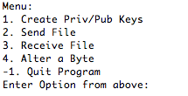 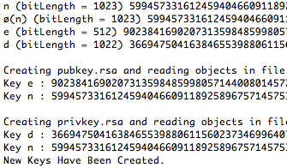

To “Send” a file, you must select the option on the menu. It will prompt you for the file you wish to send. If you select the wrong file, it will inform you that the file is not found, otherwise, it will output the file with a signature at the beginning of the file, with the extension “.signed”.



To “Receive” a file, you select option “3” and the will be prompted to type in the file name. If the file is not found, you will be informed by a warning. If file is found, two scenarios will take place. If the signature and message match, then the message will be displayed. If the message and signature do not match, it will output a warning.

 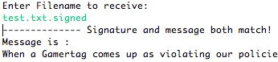

To alter a byte, select option “4”. You will be prompted to select the file name. Then choose a byte between 0 and the length of the file (in bytes). If you enter an incorrect number or input a string, you will be prompted of an invalid entry. If the input is correct, then the byte will be changed.

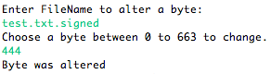

Contribution: Both members of the group cooperated very well together. Work was evenly split amongst each other and we each reviewed each other’s work for constructive criticism. Percentage for each member is %50.00